Definition Writing Strategy

Topic: ___________________________________________________ Type of Writing: _________________________________
1st Function Define your topic by telling your reader how your topic works (whatever is being written about)

3rd Negation what it is not by definition and an example

2nd Examples: give at least two examples of how it (your topic) works using comparing & contrasting, and transition words

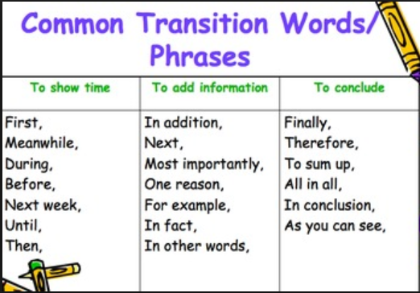

Writing Side – use your notes to write the paragraph

Plot Strategy
Title:
Type of Literature:

Climax is the point in the story when the protagonist deals with the culmination of events from rising action:

Falling Action are details of the consequences, good or bad that the characters must deal with after the climax.
Rising Action is when the protagonist encounters some sort of crisis that creates conflict:

Resolution tells what happens to the characters after the conflict is resolved and can be a happy or sad ending, but leaves readers with a sense of closure:
Exposition (author introduces the major characters, establishes the setting and reveals major conflicts in the story)

Writing Side – use your notes to write the paragraph

R.A.C.E.: Responding to constructed response essay question
1. RESTATE – Students restate the question in the form of a topic sentence.
2. ANSWER – Students answer ALL parts of the question.
3. CITE – Students cite examples from the text that support their answer.
4. EXPLAIN – Students explain how their evidence supports their answer or connects to another text.

Answer the question - make sure to answer all parts of the question.

Cite evidence from the text. - You MUST
quote the text. Use evidence based
terms to begin your sentences.
Restate the question - use the question stem to write your topic sentence.

Explain and extend - Explain how this evidence supports your answer. Give examples from connections you made.

Writing Side – use your notes to write the paragraph

Restate the question example:
What are some ways students can help to stop bullying in their school?
There are several steps students can take to help stop bullying in their
own school.
Answer the question example:
One thing students can do is to participate in a school wide effort
committed to speaking out against bullying.
Cite Evidence example:
Look back to the text to find specific examples that support your answer.
Quote the text! Using evidence based terms, begin your citation with:
“According to the author”, research has shown that students who
participate in anti-bullying programs in their schools are more likely
to have empathy for students who experience bullying.
Explain and Extend example:
Think about how your evidence from the text supports your answer,
And using your own background knowledge and experience. Here’s
an example: One example of this is a poster contest my school had.
The topic was “Stand up to Bullies.” The contest seemed to make
students really think about how hurtful bullying can be.

5Ws Literary & Informational Text Writing Strategy
After reading your literature or informational text use the 5Ws to analyze and summarize what your have read. Which “W” you begin with depends on the type of text and what you want your reader to know first. “Why” = is the text important. “Who” = is writing the text or what character is telling the story and/or is it written in 1st, 2nd or 3rd Person. “What” = the conflict type or main idea or purpose for writing (inform, persuade, entertain). “When” = time, day or year. “Where” = is the location i.e. at night, on a street or a very specific place.

Why
_____________________________________________________________________________________________________________
What
Wh0
____________________________________________________________________________________________________________
____________________________________________________________________________________________________________
__________________________________________________________________________________________________________
____________________________________________________________________________________________________________
_____________________________________________________________________________________________________________
____________________________________________________________________________________________________________
____________________________________________________________________________________________________________
Where
__________________________________________________________________________________________________________
When
____________________________________________________________________________________________________________
____________________________________________________________________________________________________________
____________________________________________________________________________________________________________

Writing Side – use your notes to write the paragraph

_____________________________________________________________________________________________________________
____________________________________________________________________________________________________________
____________________________________________________________________________________________________________
____________________________________________________________________________________________________________
____________________________________________________________________________________________________________
_____________________________________________________________________________________________________________
____________________________________________________________________________________________________________
____________________________________________________________________________________________________________
____________________________________________________________________________________________________________
____________________________________________________________________________________________________________
____________________________________________________________________________________________________________
____________________________________________________________________________________________________________

Ideas & Organization Web Writing
Directions: Write your topic (main idea), then write a supporting detail about the topic. Next number the order of each idea (this is organization). Think about which detail you want to come 1st, 2nd or 3rd, etc. Lastly, begin writing your paragraph using complete sentences.

Topic

Writing Standard(s):

Writing Side – use your notes to write the paragraph

